Dataset link

1. <https://www.kaggle.com/datasets/kmldas/loan-default-prediction>
2. <https://www.kaggle.com/datasets/subhamjain/loan-prediction-based-on-customer-behavior>
3. <https://www.kaggle.com/datasets/devzohaib/eligibility-prediction-for-loan>
4. <https://github.com/shrikant-temburwar/Loan-Prediction-Dataset/blob/master/train.csv>
5. 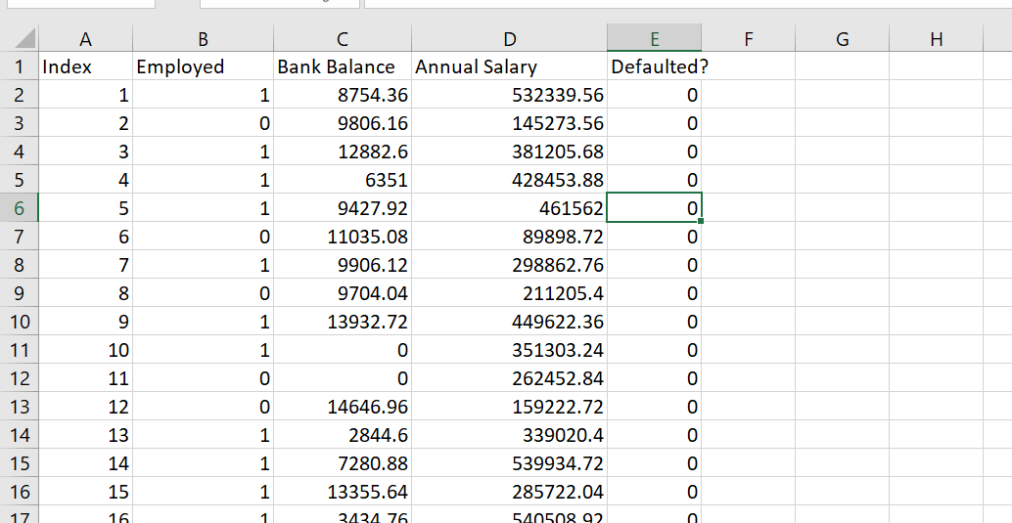10000 rows but 3 attribute

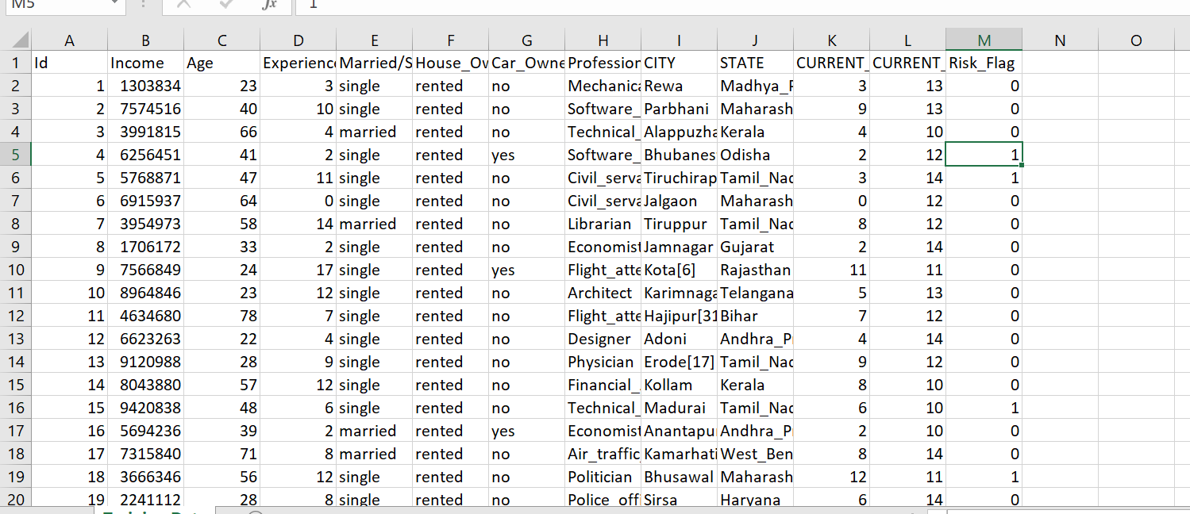2.25200 rows

3. 615 rows

4. 615 rows